SetInterval And SetTimeout

# SetTimeout

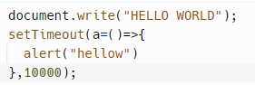

//here 10000 is the timeinterval which is 10s;

**And use a function inside the setTimeout**

And it will show you a alert prompt after 10s;

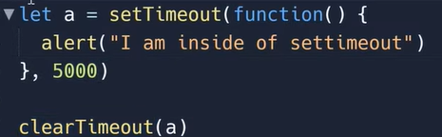

Let a=setTimeout……

**clearTimeout(timerid)**

**//how tofind timer id?**

**Console.log(a)**

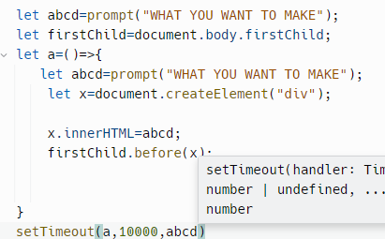

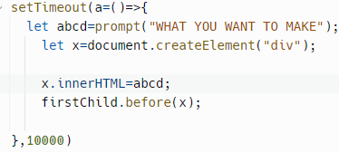

## setInterval();

setInterval(sum=()=>{

let a=prompt(“enter first number”);

a=Number.parseInt(a);

let b=prompt(“enter second number”);

b=Number.parseInt(b);

let sum=a+b;

console.log(sum);

},10000,//if my function was taking some input from outside (I will write it here));

clearInterval(timerid)

//timerid by console.log(and use a variable before the setInterval fucntion)

## setInterval();

